AIPP LAB 6
Name: SANIYA TAHSEEN
Hall Ticket No.: 2503B05122
___________________________________________________
Completed this Assignment using Cursor Al Integration.
Task 1:
Use AI to complete a Student class with attributes and a Constructor method.
CODE:
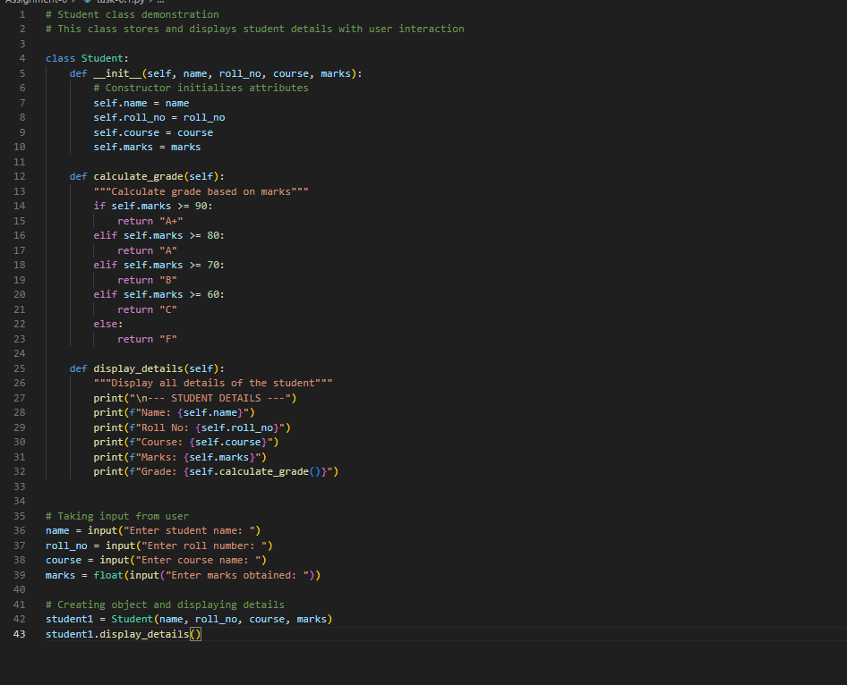

OUTPUT:
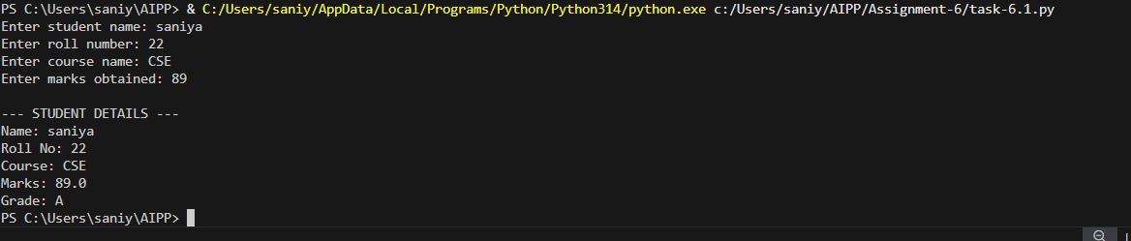
Task 2:
Prompt AI to complete a function that prints the first 10 multiples of a number using a loop.
CODE:
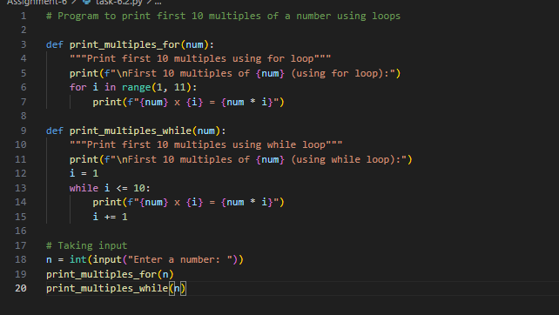OUTPUT:
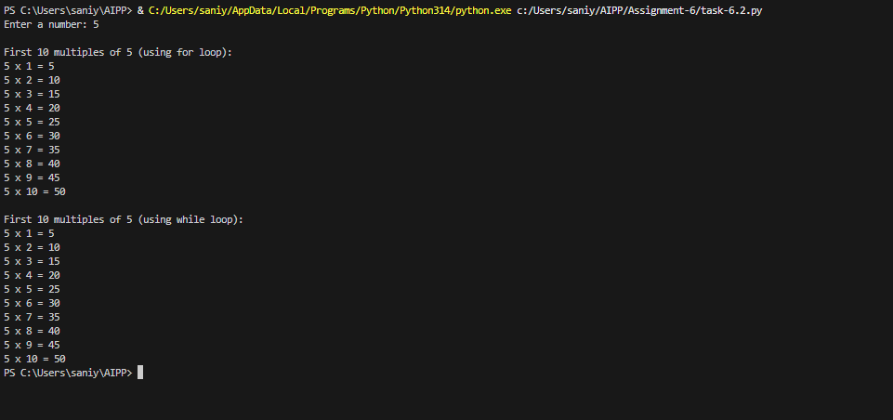Task 3:
Ask AI to write Nested if-elif-else conditionals to classify age groups.
CODE:
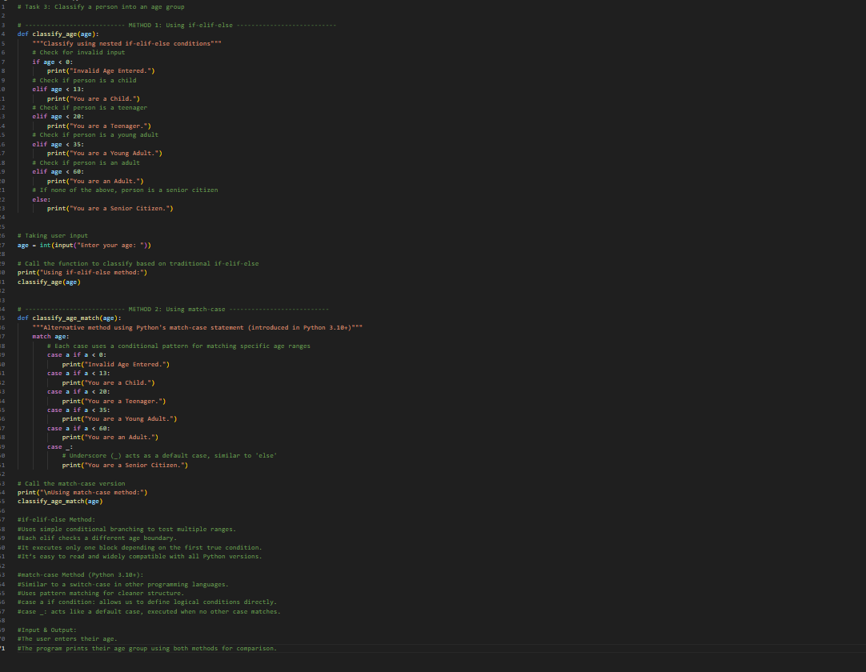

OUTPUT:
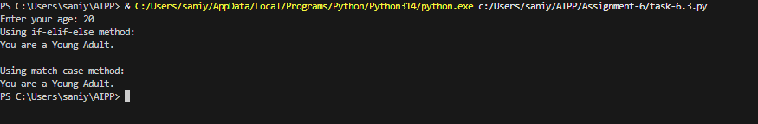
Task 4:
Generate a sum_to_n() function to calculate sum of first n numbers
CODE:
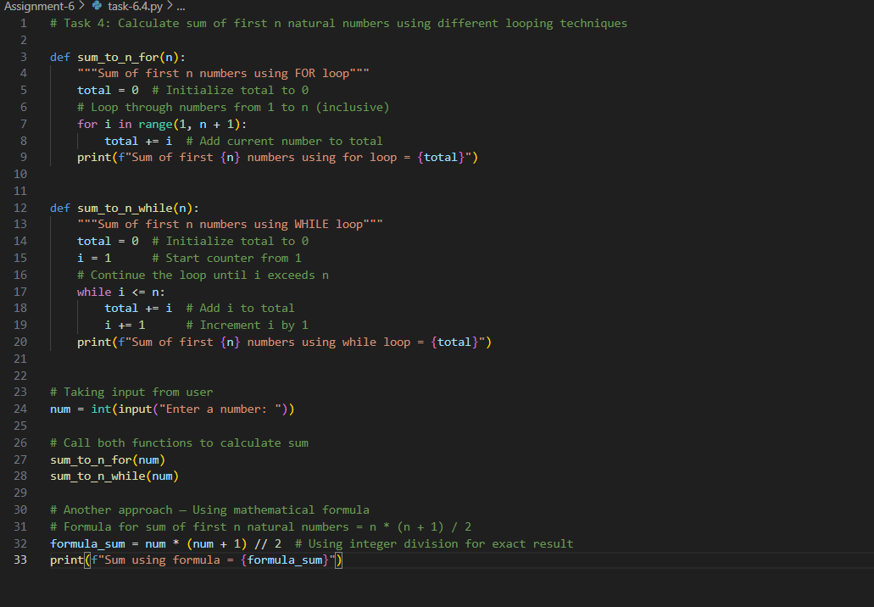
OUTPUT:
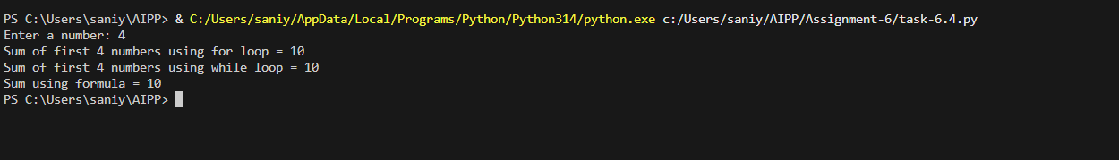
Task 5:
Use AI to build a BankAccount class with deposit, withdraw, and balance methods.
CODE:
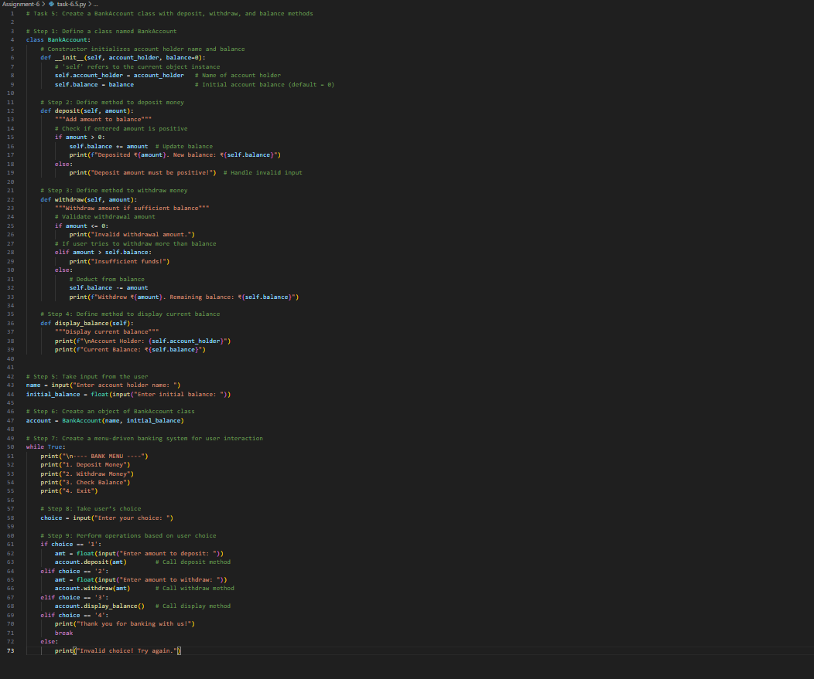

OUTPUT:



